Depth Gauge
# Source: AI Source: Provided by: [Data Path: Persons Table -> ID Column: 1, Name_En Column: Motasem Essam] -> From: [ChatGPT] on [7/17/2026]
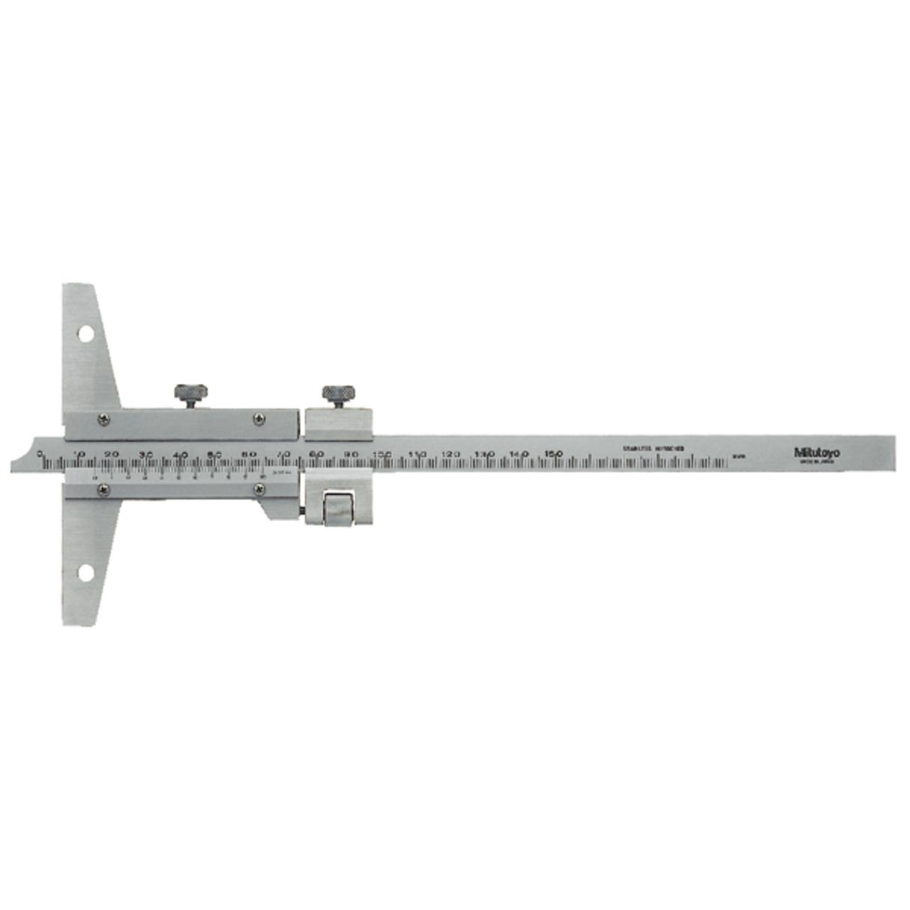
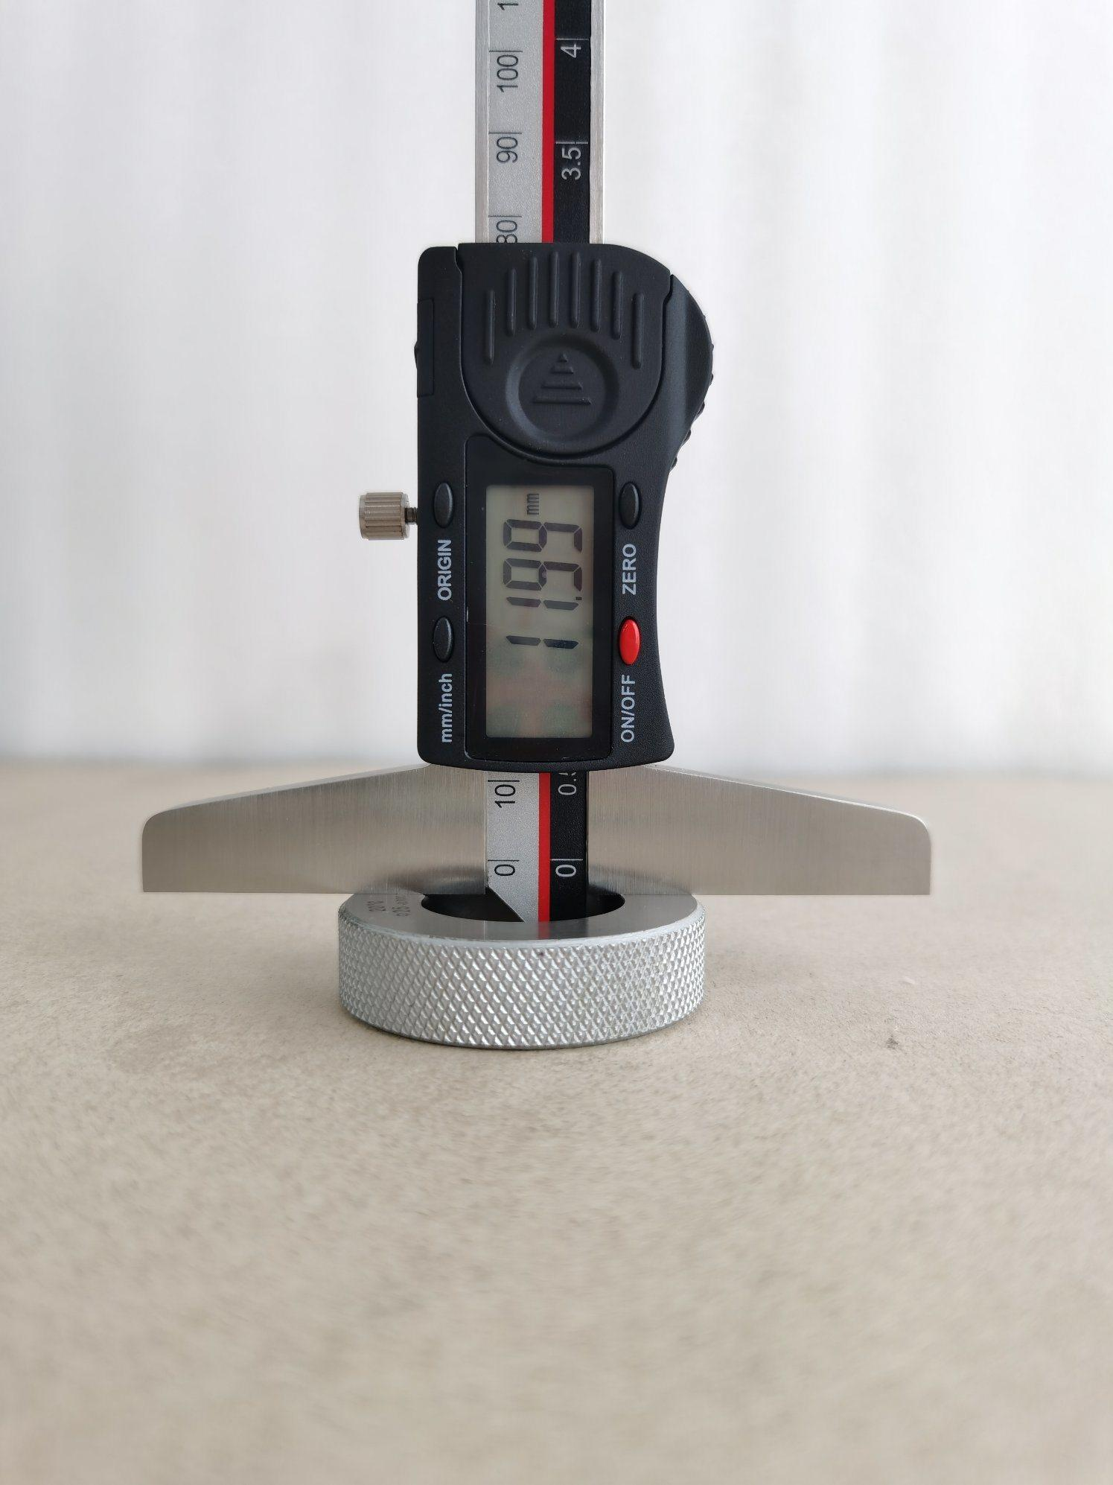
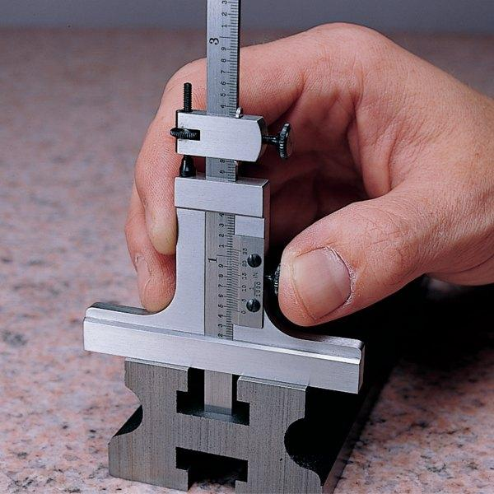
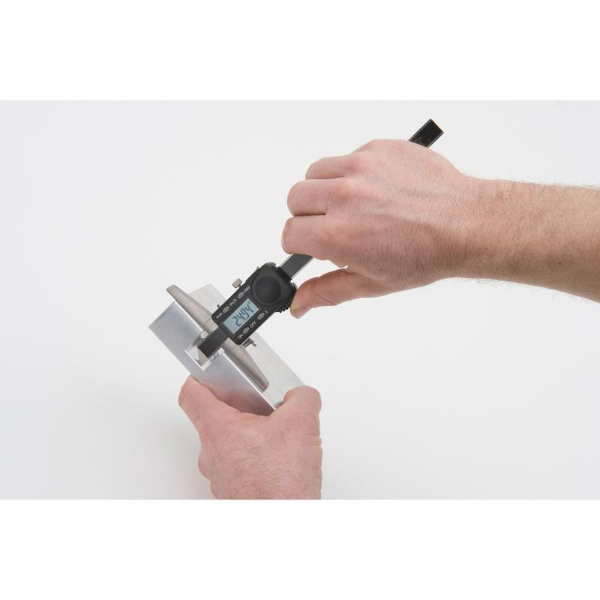
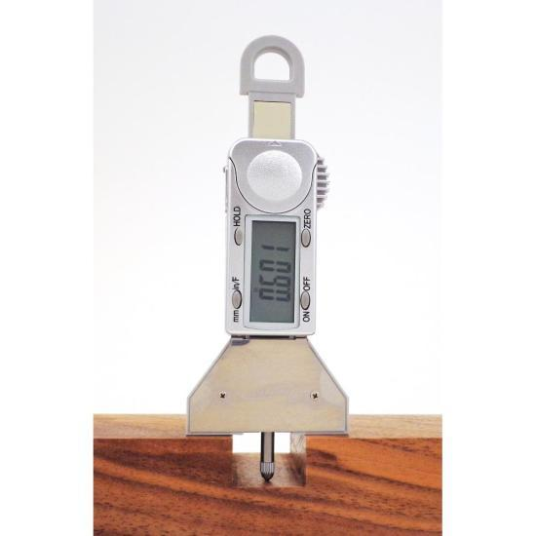
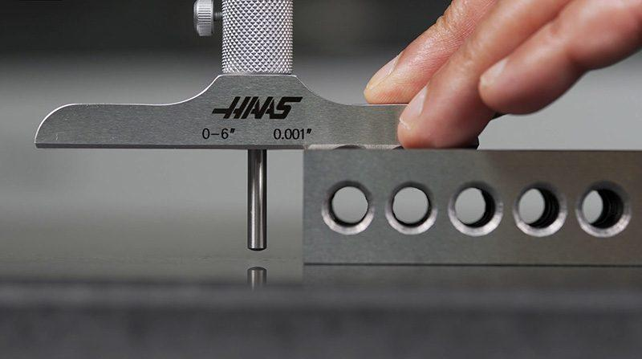
A Depth Gauge is a precision measuring instrument used to measure the depth of holes, slots, grooves, recesses, and steps. It provides accurate depth measurements that cannot be easily obtained with a ruler or measuring tape.
Depth gauges are widely used in mechanical engineering, machining, manufacturing, metrology, automotive maintenance, quality control, and inspection.

Definition
# Source: AI Source: Provided by: [Data Path: Persons Table -> ID Column: 1, Name_En Column: Motasem Essam] -> From: [ChatGPT] on [7/17/2026]
A Depth Gauge is a precision measuring instrument designed to accurately determine the depth of holes, grooves, slots, recesses, and other internal features from a reference surface.

Purpose
# Source: AI Source: Provided by: [Data Path: Persons Table -> ID Column: 1, Name_En Column: Motasem Essam] -> From: [ChatGPT] on [7/17/2026]
A Depth Gauge is used to:
- Measure hole depth.
- Measure groove depth.
- Measure slot depth.
- Measure recess depth.
- Measure counterbore depth.
- Inspect machined components.
- Verify dimensional tolerances.

Principle of Operation
# Source: AI Source: Provided by: [Data Path: Persons Table -> ID Column: 1, Name_En Column: Motasem Essam] -> From: [ChatGPT] on [7/17/2026]
A depth gauge operates by:
- Placing its base firmly on the reference surface.
- Extending the measuring rod into the hole or recess until it touches the bottom.
- Reading the measurement using a Vernier scale, dial indicator, or digital display.

Main Components
# Source: AI Source: Provided by: [Data Path: Persons Table -> ID Column: 1, Name_En Column: Motasem Essam] -> From: [ChatGPT] on [7/17/2026]
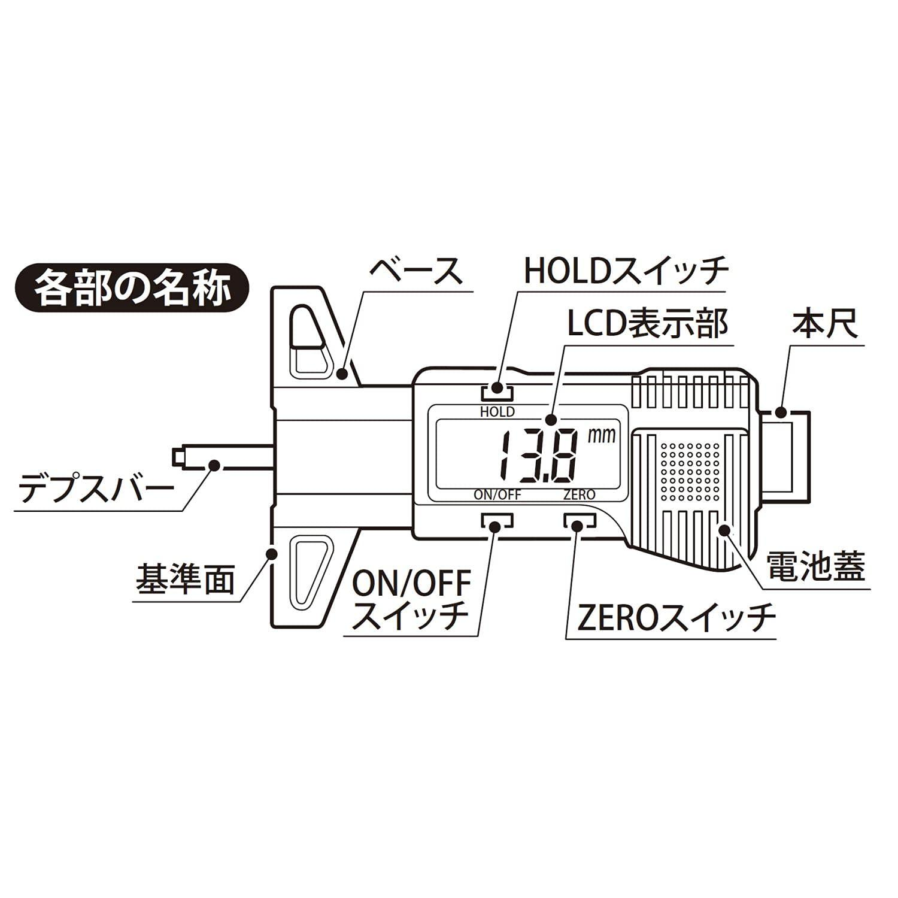
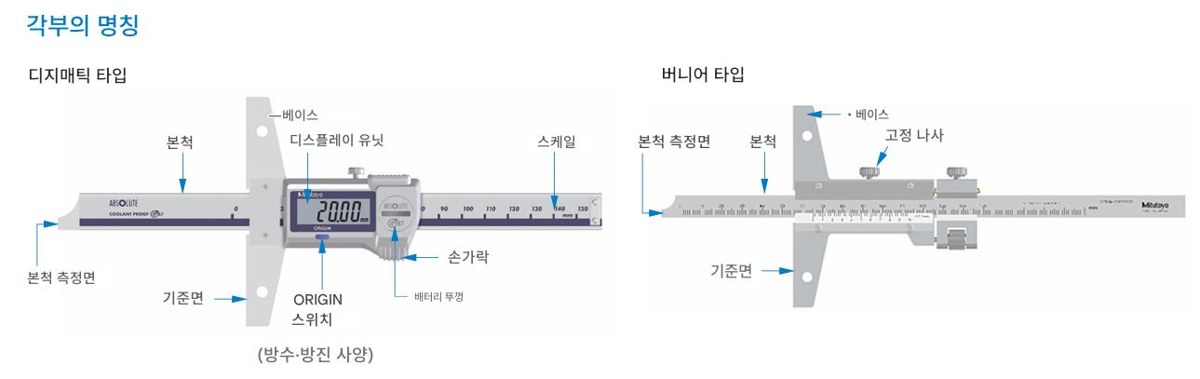
A typical Depth Gauge consists of:
- Flat reference base
- Measuring rod (depth probe)
- Main scale
- Vernier scale, dial, or digital display
- Slider
- Locking screw
- Fine adjustment mechanism (on some models)

Types of Depth Gauges

1. Vernier Depth Gauge
# Source: AI Source: Provided by: [Data Path: Persons Table -> ID Column: 1, Name_En Column: Motasem Essam] -> From: [ChatGPT] on [7/17/2026]
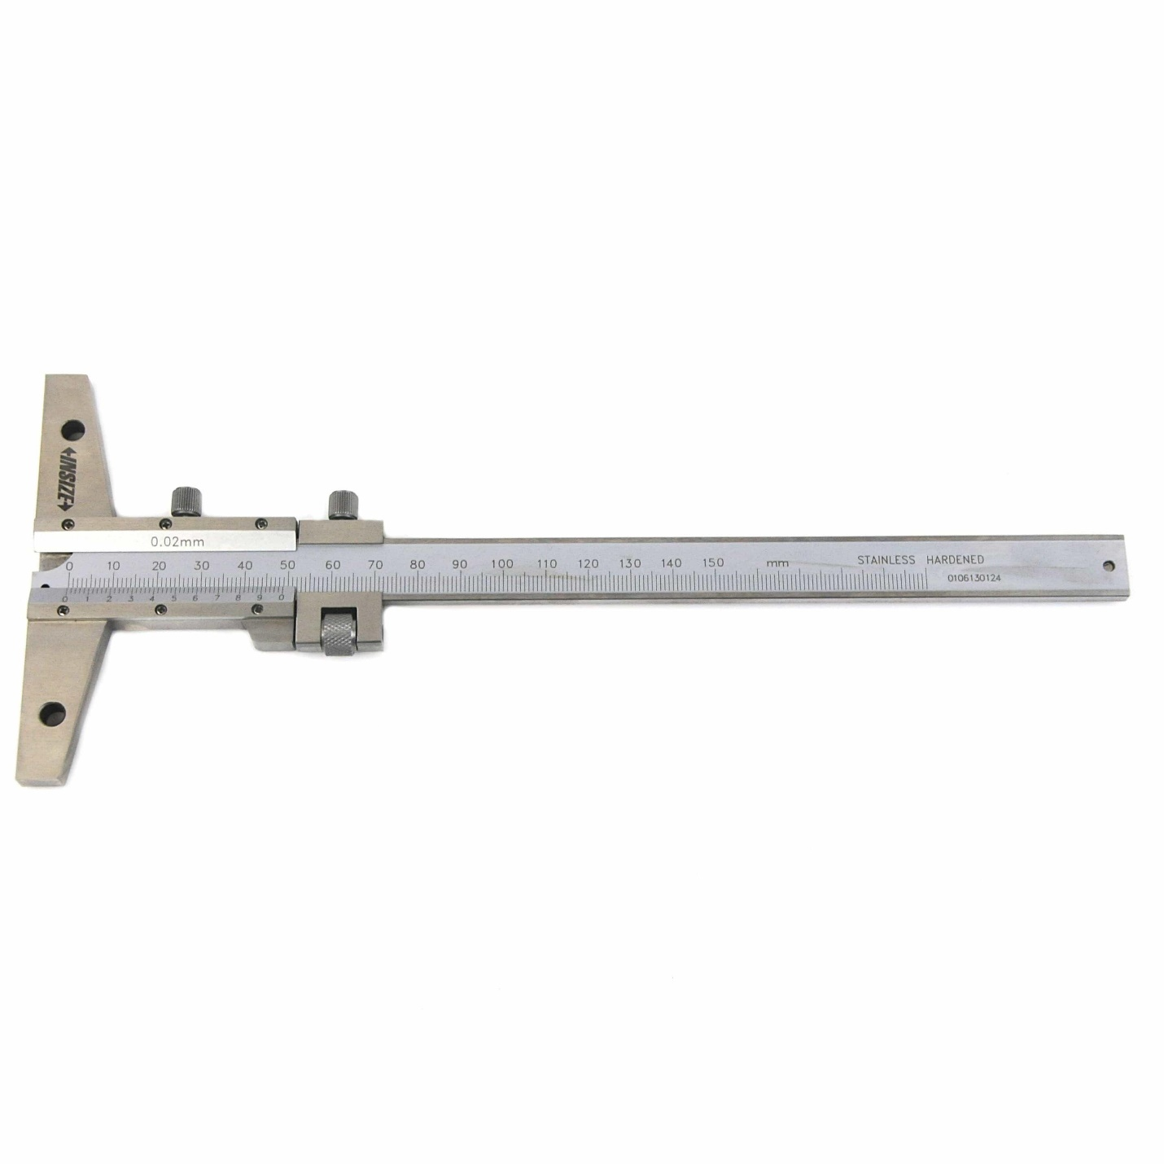

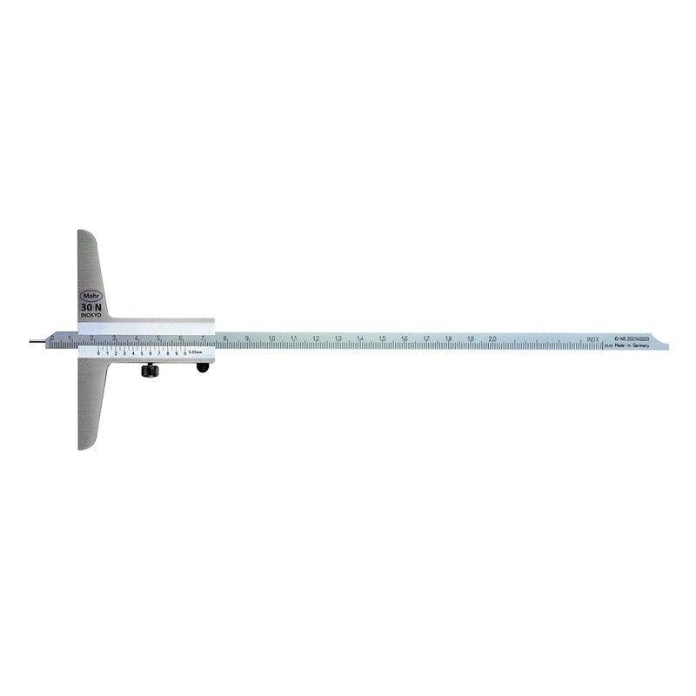
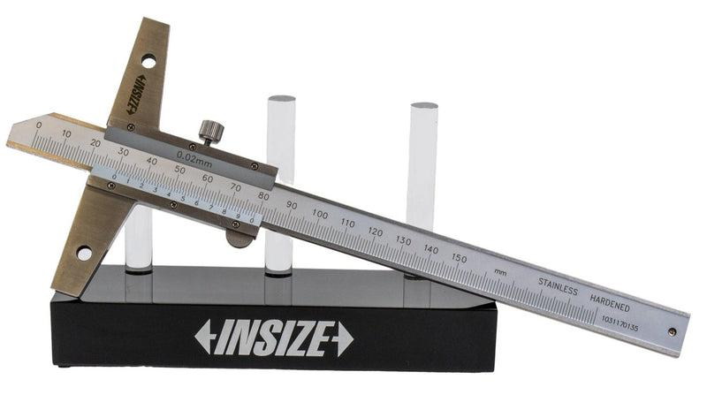
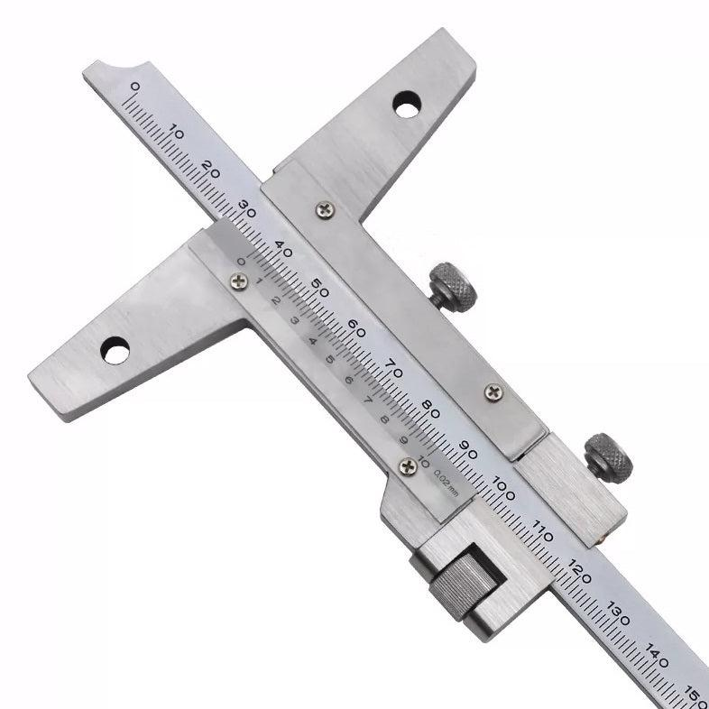
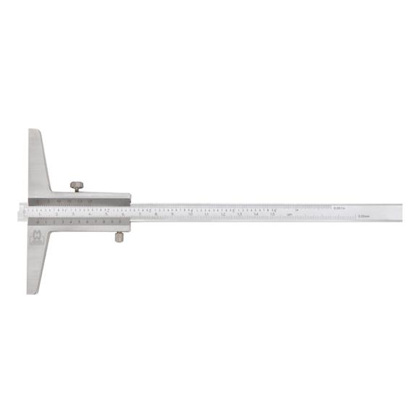
Description
Uses a main scale and vernier scale to measure depth manually with high precision.
Typical Least Count
- 0.02 mm
Applications
- Machine shops
- Workshop inspection
- General engineering

2. Dial Depth Gauge
# Source: AI Source: Provided by: [Data Path: Persons Table -> ID Column: 1, Name_En Column: Motasem Essam] -> From: [ChatGPT] on [7/17/2026]
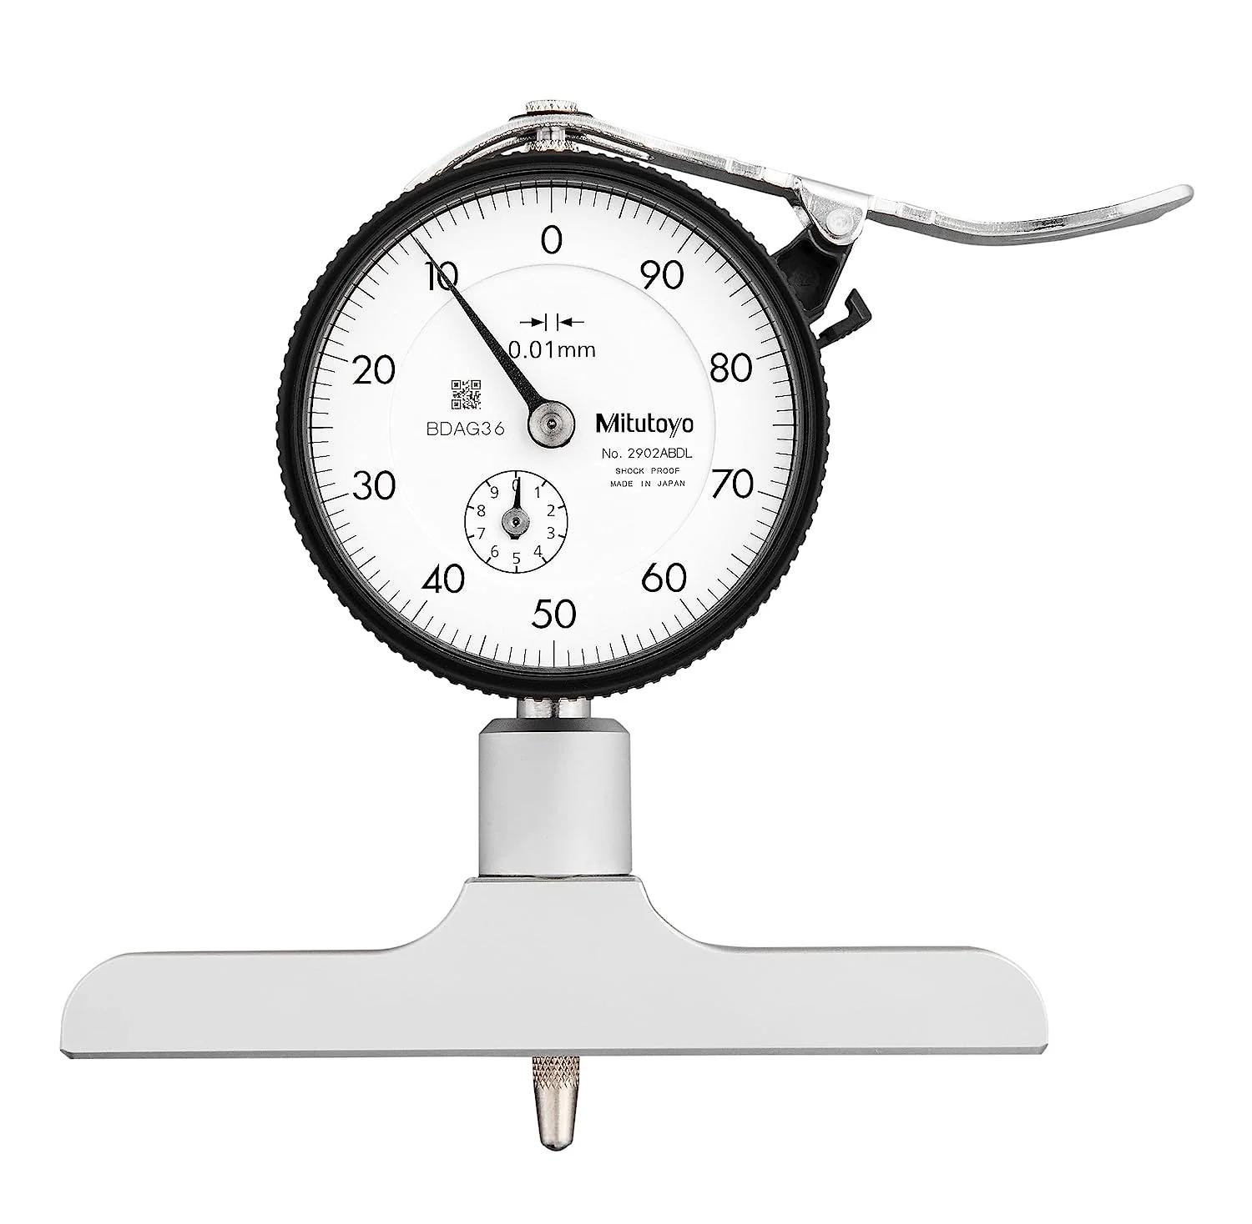
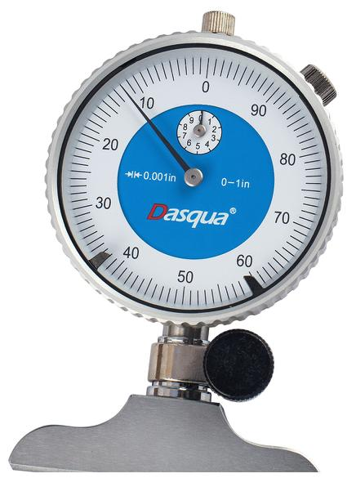
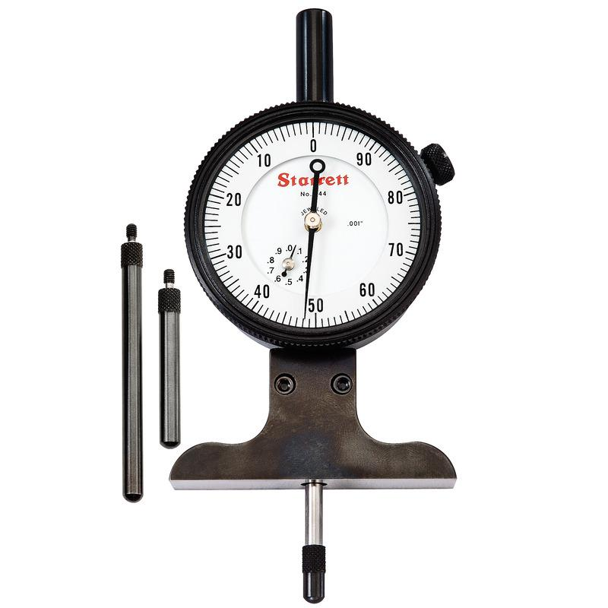
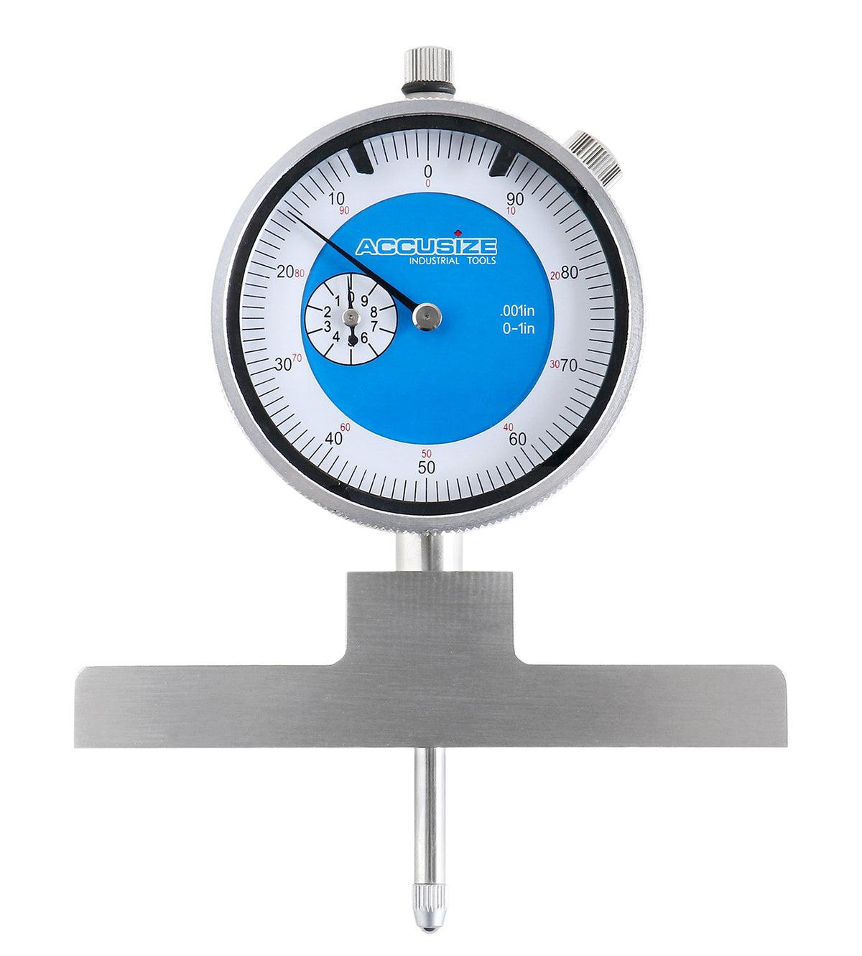
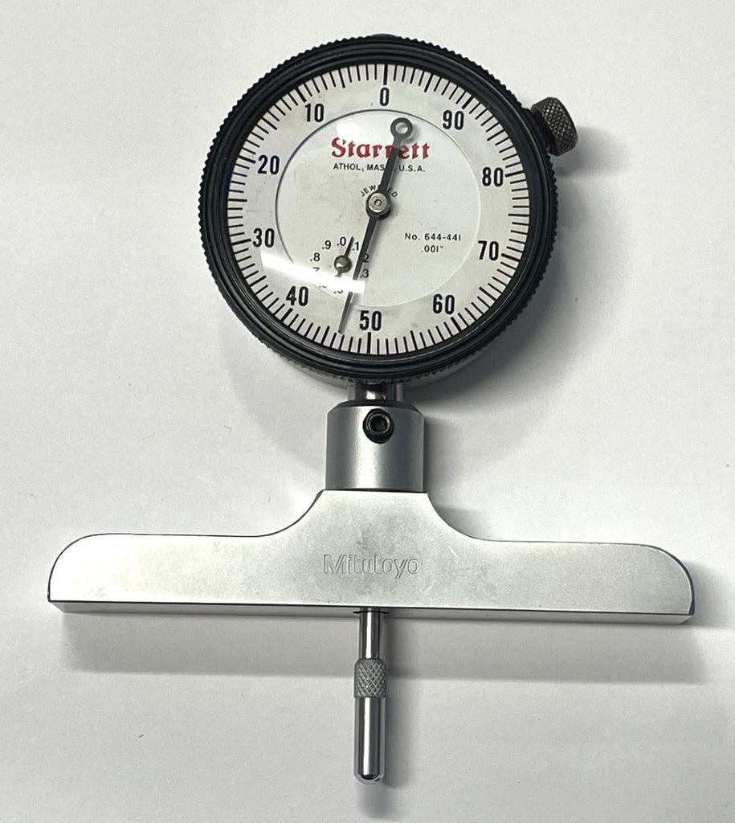
Description
Uses a dial indicator to provide easier reading than a vernier scale.
Typical Least Count
- 0.01 mm
- 0.02 mm
Applications
- Quality inspection
- Manufacturing
- Tool rooms

3. Digital Depth Gauge
# Source: AI Source: Provided by: [Data Path: Persons Table -> ID Column: 1, Name_En Column: Motasem Essam] -> From: [ChatGPT] on [7/17/2026]
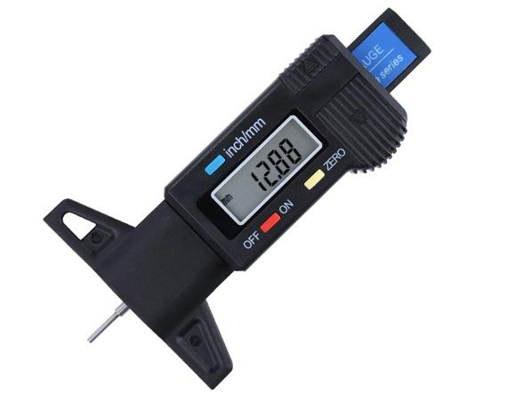
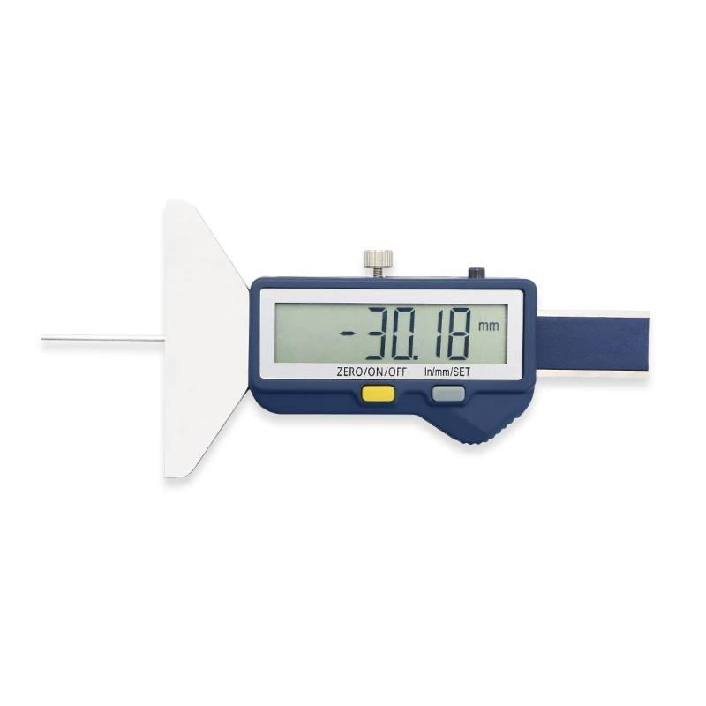
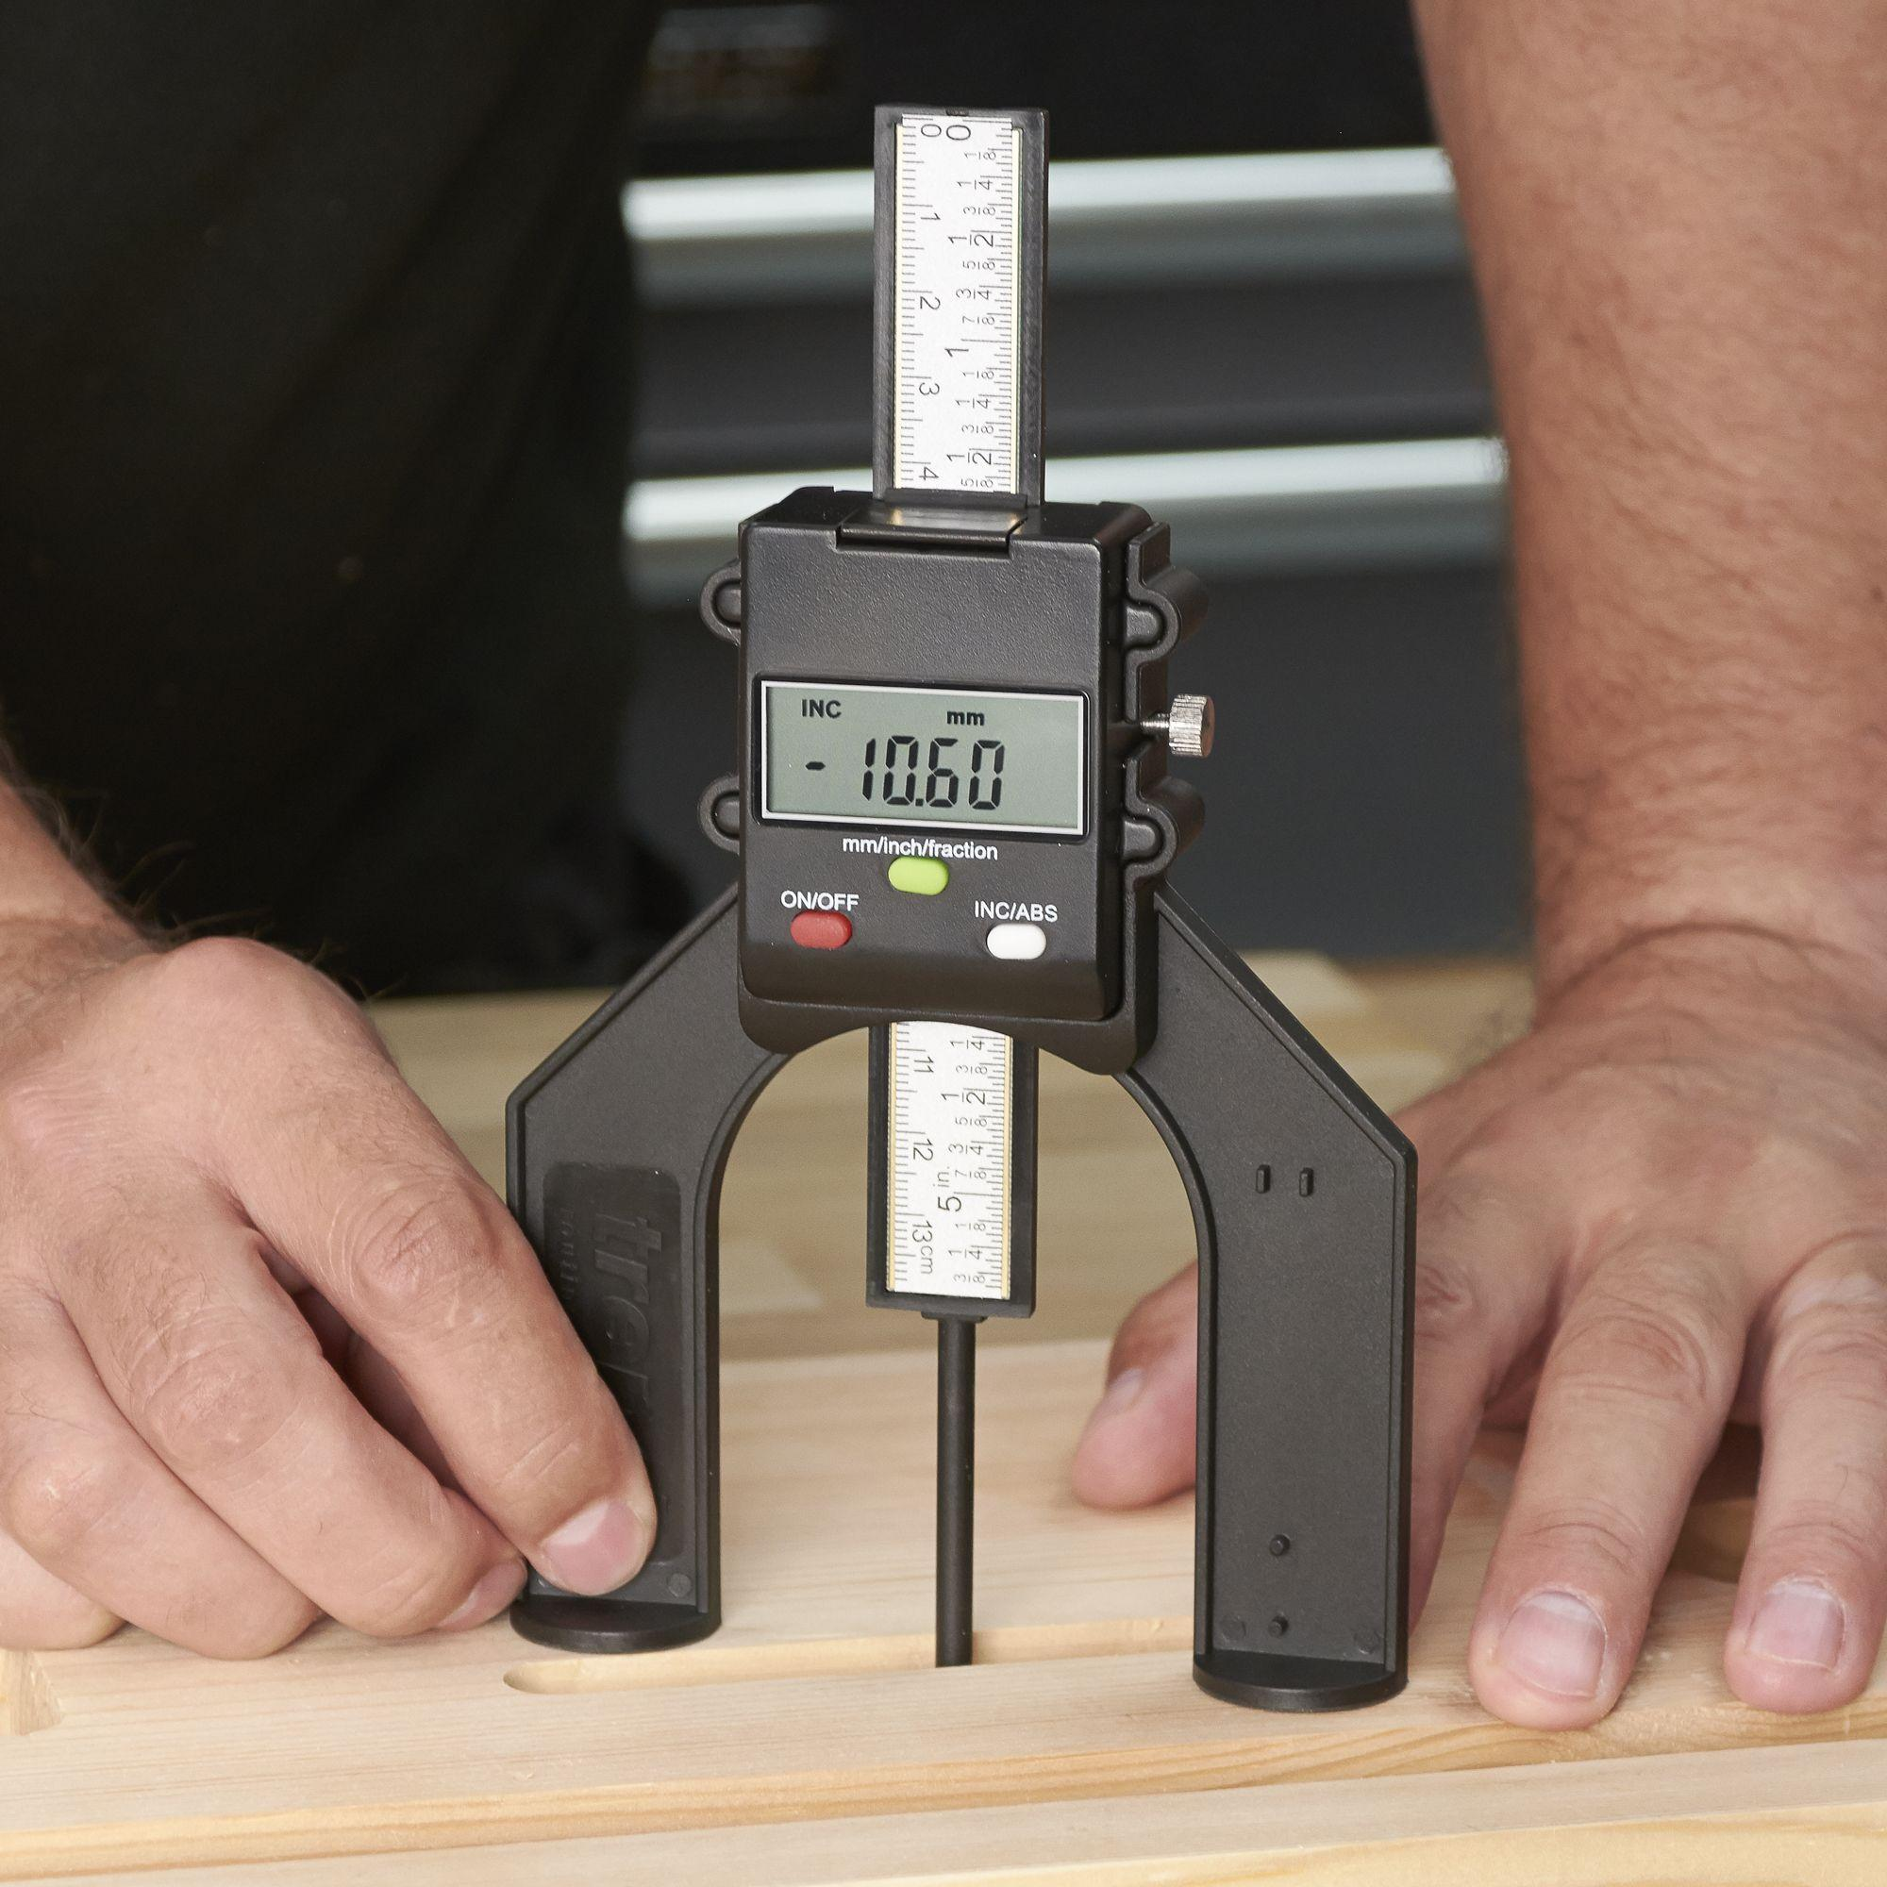
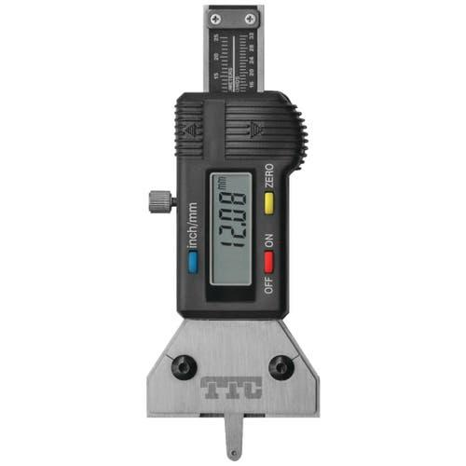
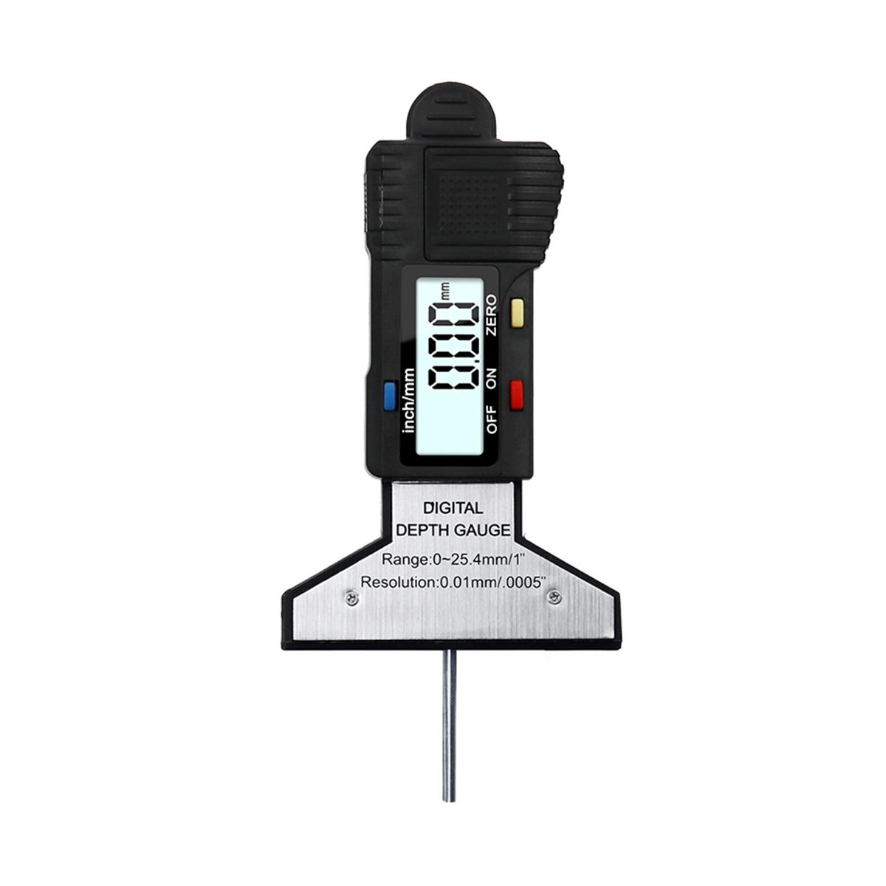
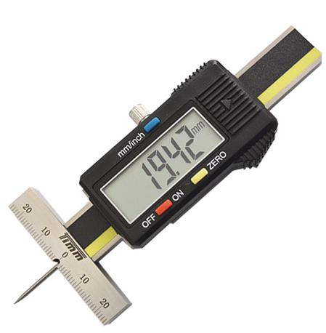
Description
Uses an electronic sensor and LCD display to provide direct digital readings.
Features
- Digital display
- Metric/Imperial conversion
- Zero setting
- High precision
Typical Least Count
- 0.01 mm
- 0.001 mm (high-end models)
Applications
- Precision machining
- Metrology laboratories
- CNC inspection

4. Micrometer Depth Gauge
# Source: AI Source: Provided by: [Data Path: Persons Table -> ID Column: 1, Name_En Column: Motasem Essam] -> From: [ChatGPT] on [7/17/2026]
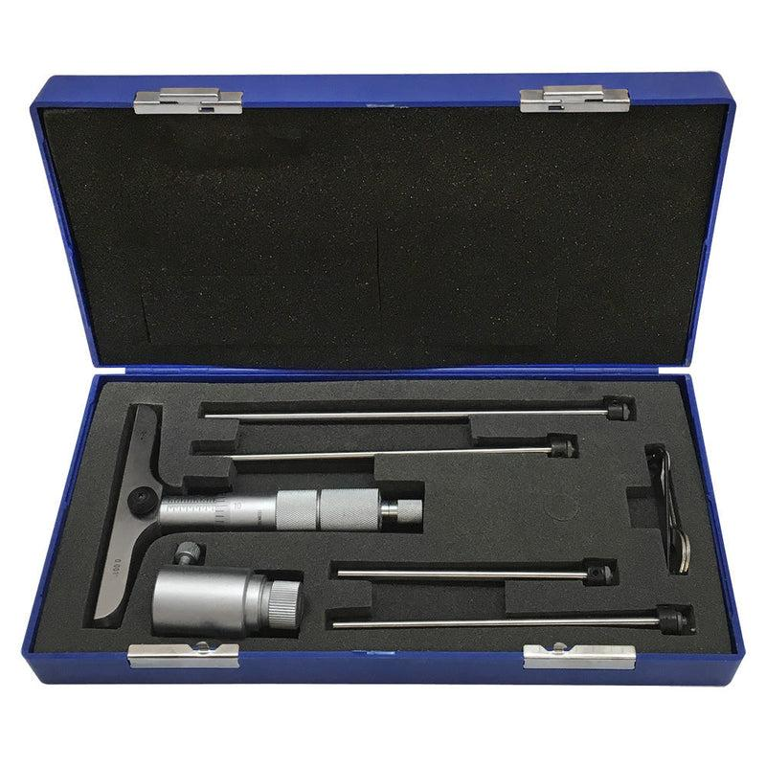
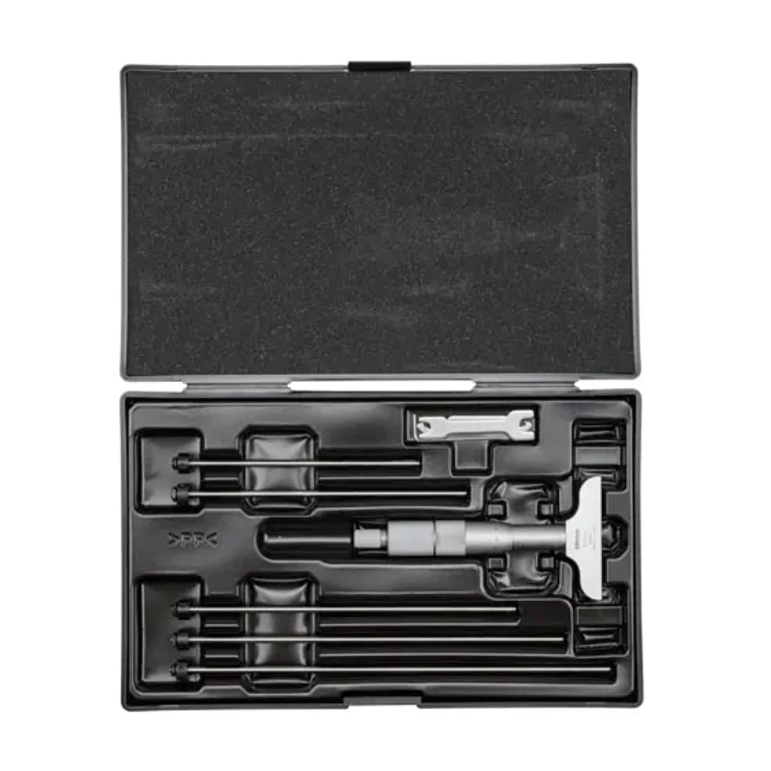
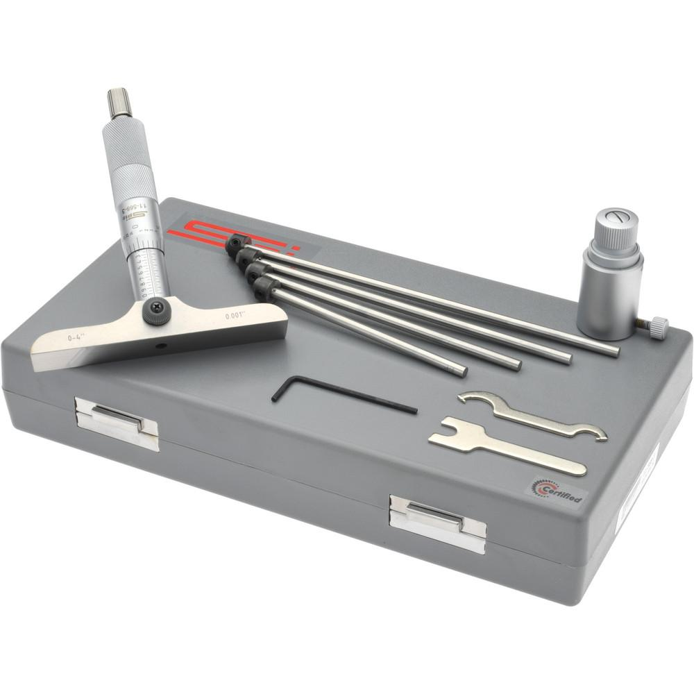
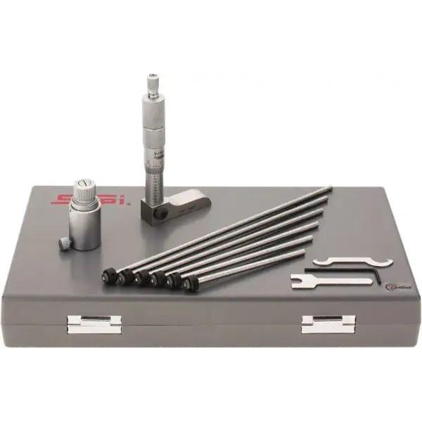
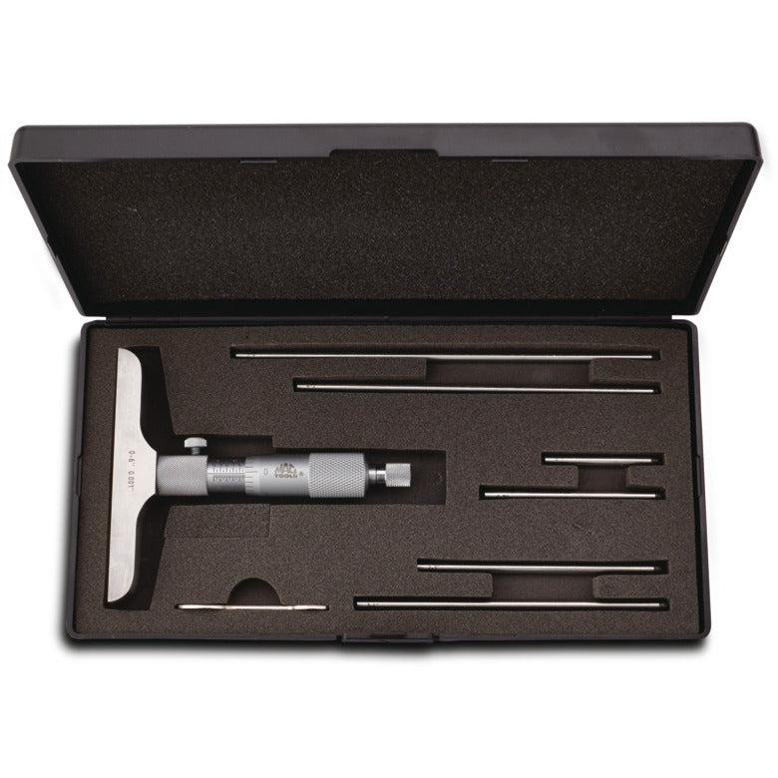
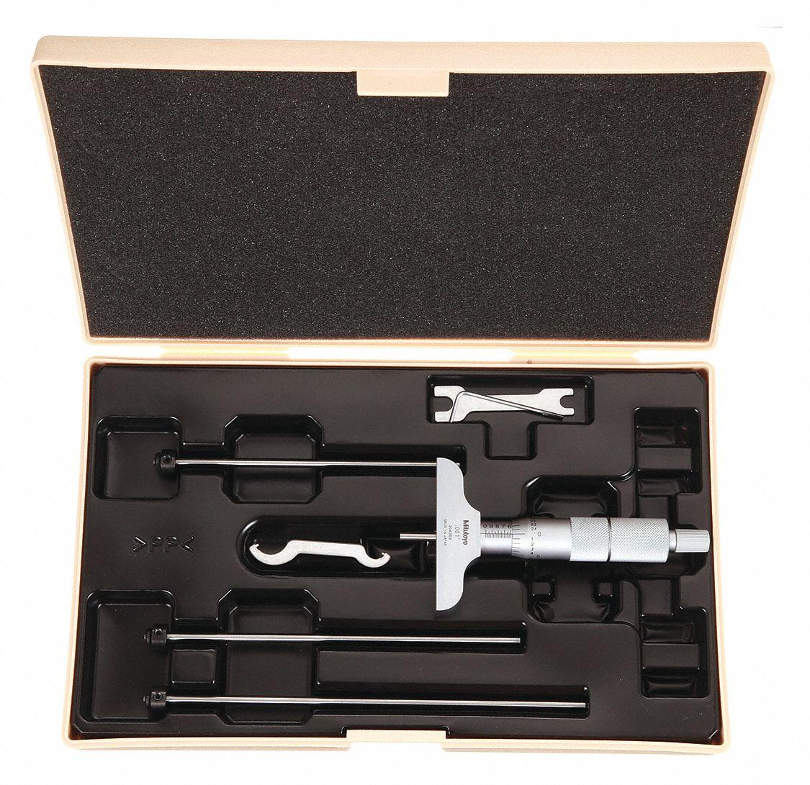
Description
Uses a micrometer screw mechanism to achieve extremely precise depth measurements.
Typical Least Count
- 0.01 mm
- 0.001 mm
Applications
- Precision engineering
- High-accuracy inspection
- Laboratory measurements

Measuring Range
# Source: AI Source: Provided by: [Data Path: Persons Table -> ID Column: 1, Name_En Column: Motasem Essam] -> From: [ChatGPT] on [7/17/2026]
Common measuring ranges:
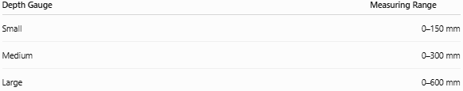
Depth Gauge | Measuring Range
Small | 0–150 mm
Medium | 0–300 mm
Large | 0–600 mm
Micrometer depth gauges often use interchangeable rods to cover larger ranges.

Least Count (Resolution)
# Source: AI Source: Provided by: [Data Path: Persons Table -> ID Column: 1, Name_En Column: Motasem Essam] -> From: [ChatGPT] on [7/17/2026]
Typical values:
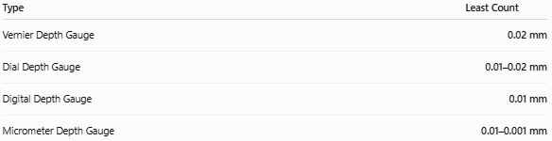
Type | Least Count
Vernier Depth Gauge | 0.02 mm
Dial Depth Gauge | 0.01–0.02 mm
Digital Depth Gauge | 0.01 mm
Micrometer Depth Gauge | 0.01–0.001 mm

How to Measure with a Depth Gauge
# Source: AI Source: Provided by: [Data Path: Persons Table -> ID Column: 1, Name_En Column: Motasem Essam] -> From: [ChatGPT] on [7/17/2026]
- Clean the reference surface and the feature to be measured.
- Place the base flat on the reference surface.
- Lower or extend the measuring rod until it gently contacts the bottom of the hole or recess.
- Lock the slider (if applicable).
- Read the measurement.
- Record the result with the correct unit.

Example
# Source: AI Source: Provided by: [Data Path: Persons Table -> ID Column: 1, Name_En Column: Motasem Essam] -> From: [ChatGPT] on [7/17/2026]
Suppose the display shows:
18.64 mm
The measured depth is:
- 18.64 mm
- 1.864 cm
- 0.01864 m

Accuracy
# Source: AI Source: Provided by: [Data Path: Persons Table -> ID Column: 1, Name_En Column: Motasem Essam] -> From: [ChatGPT] on [7/17/2026]
Typical accuracy:
- ±0.02 mm
- ±0.01 mm
- Better on precision digital and micrometer models
Accuracy depends on:
- Calibration
- Surface cleanliness
- Proper base contact
- Instrument quality
- Temperature

Sources of Error
# Source: AI Source: Provided by: [Data Path: Persons Table -> ID Column: 1, Name_En Column: Motasem Essam] -> From: [ChatGPT] on [7/17/2026]
Instrument Errors
- Calibration error
- Worn measuring rod
- Damaged scale
- Loose slider

Observation Errors
- Incorrect reading
- Parallax (analog models)
- Recording errors

Positioning Errors
- Base not fully seated on the reference surface
- Measuring rod not touching the true bottom
- Measuring at an angle

Environmental Errors
- Dust
- Oil film
- Thermal expansion
- Vibration

Applications
# Source: AI Source: Provided by: [Data Path: Persons Table -> ID Column: 1, Name_En Column: Motasem Essam] -> From: [ChatGPT] on [7/17/2026]
Depth Gauges are used in:
- Mechanical engineering
- Manufacturing
- CNC machining
- Tool making
- Automotive industry
- Aerospace
- Metrology laboratories
- Quality control
- Inspection departments

Advantages
# Source: AI Source: Provided by: [Data Path: Persons Table -> ID Column: 1, Name_En Column: Motasem Essam] -> From: [ChatGPT] on [7/17/2026]
A Depth Gauge:
- Measures depths accurately.
- Is easy to operate.
- Provides repeatable measurements.
- Is available in analog and digital forms.
- Can inspect features that are inaccessible to rulers.

Limitations
# Source: AI Source: Provided by: [Data Path: Persons Table -> ID Column: 1, Name_En Column: Motasem Essam] -> From: [ChatGPT] on [7/17/2026]
A Depth Gauge:
- Measures only depth-related dimensions.
- Requires a clean, flat reference surface.
- Is less versatile than a Vernier caliper for general measurements.
- Requires periodic calibration.

Comparison with Other Length Measuring Instruments
# Source: AI Source: Provided by: [Data Path: Persons Table -> ID Column: 1, Name_En Column: Motasem Essam] -> From: [ChatGPT] on [7/17/2026]
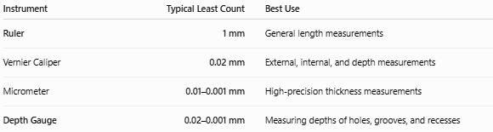
Instrument | Typical Least Count | Best Use
Ruler | 1 mm | General length measurements
Vernier Caliper | 0.02 mm | External, internal, and depth measurements
Micrometer | 0.01–0.001 mm | High-precision thickness measurements
Depth Gauge | 0.02–0.001 mm | Measuring depths of holes, grooves, and recesses

Care and Maintenance
# Source: AI Source: Provided by: [Data Path: Persons Table -> ID Column: 1, Name_En Column: Motasem Essam] -> From: [ChatGPT] on [7/17/2026]
To maintain accuracy:
- Keep the base and measuring rod clean.
- Protect the measuring rod from bending.
- Store the instrument in a protective case.
- Avoid impacts.
- Calibrate regularly.
- Lightly oil steel components when recommended.

Common Mistakes
# Source: AI Source: Provided by: [Data Path: Persons Table -> ID Column: 1, Name_En Column: Motasem Essam] -> From: [ChatGPT] on [7/17/2026]
- Measuring on a dirty surface.
- Tilting the instrument.
- Applying excessive pressure to the measuring rod.
- Reading the wrong scale on analog models.
- Forgetting to check for zero error.

Key Points
# Source: AI Source: Provided by: [Data Path: Persons Table -> ID Column: 1, Name_En Column: Motasem Essam] -> From: [ChatGPT] on [7/17/2026]
- A Depth Gauge measures the depth of holes, slots, grooves, and recesses.
- It consists of a flat base and a measuring rod.
- Common types:
  - Vernier Depth Gauge
  - Dial Depth Gauge
  - Digital Depth Gauge
  - Micrometer Depth Gauge
- Typical least count ranges from 0.02 mm to 0.001 mm.
- It is widely used in machining, manufacturing, inspection, and quality control.

Conclusion
# Source: AI Source: Provided by: [Data Path: Persons Table -> ID Column: 1, Name_En Column: Motasem Essam] -> From: [ChatGPT] on [7/17/2026]
A Depth Gauge is a precision measuring instrument specifically designed to determine the depth of internal features such as holes, grooves, slots, and recesses. By using a stable reference base and a precision measuring rod, it provides accurate and repeatable depth measurements that are essential in engineering, machining, manufacturing, metrology, and quality control. Available in vernier, dial, digital, and micrometer versions, the depth gauge is an indispensable tool whenever precise depth measurement is required.

